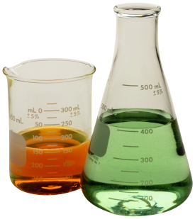 Honors Chemistry 2018 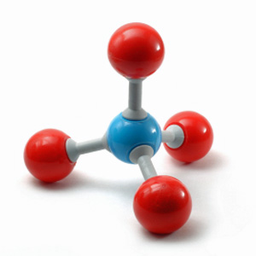
Middle Creek High School

Ms. Kathie DeMonte
Email: kdemonte@wcpss.net
Website: msdemonte.weebly.com
Course Description
Chemistry is the study of matter and energy. Honors Chemistry requires you to conceptualize scientific concepts, as well use your math skills to solve mathematical problems. Because of this, it is recommended, but not required that all students have completed Honors Common Core Math II. Chemistry is the type of class that builds on itself, requiring you to master each topic in order to proceed to the next one. This class moves at a fast pace and requires the student to stay on top of a rigorous work load.

Topics
Throughout this school year, we will be covering many topics. Below is a list of the topics that will be discussed.

- Foundational Skills  - Atomic Structure  - Periodic Table  - Bonding/Nomenclature  - Chemical Reactions  - The Mole | - Stoichiometry  - Properties of Gases  - Thermochemistry  - Solutions  - Acids and Bases  - Equilibrium  - Nuclear
Expectations
Students are expected to show up to class, on time, every day, and ready to learn with all necessary materials. When in class, students should turn in anything that is due to the front table, pick up any new handouts from the front bin, and should begin the Do Now when the bell rings. Students are expected to complete all required work and to get help when needed. Students are to be respectful to themselves, students around them, the school’s property, and myself.

Supplies
Below is a list of supplies that students need to bring to class every day.
- A Large 3-ring binder – Students will be receiving a lot of handouts!
- Scientific or graphing calculator
- Graph Paper

Class Format
This class is structured as a “flipped classroom”. This means that students will watch videos of me delivering material and taking notes on those lectures. This allows us to have more time in class to work with the teacher and other students on doing practice problems, activities, and labs.
Grades
All grades will be out of 100 points and then be multiplied by the following grading scale:

Percent of Grade
Tests 50
Major Labs 20
Minor Labs 10
Quizzes 15
Classwork/Homework 5

Homework
Homework will be assigned every night and can be found on the unit schedule and on the class website. Homework will usually be to watch and take notes on a video, but it can also include (and is expected) for students to finish any classwork that was not completed in class, or any additional practice problems.

Late Work
You will receive four “Life Happens Passes” for the semester. This allows you to turn in an assignment 1 school day late without any percentage deduction. You can only use one late pass per assignment. These passes CANNOT be used on video notes! Without a late pass, 20% will be deducted per day late. After 5 days past the assignments due date there will be a 50% deduction. Late work will be graded after all current work is graded.

Absences
It is important that you come to school every day. We will be doing a lot of activities in class that you need to be present for to help you better understand the material. In the case that you are absent, follow the unit schedule provided to you to know what to complete when not in class. You are expected to stay on track even when absent. Being absent is not an excuse for falling behind or not completing homework!
- Please come speak to me if you are concerned about make up work.
- Any work that was due on the day you missed, is due the day you return to school.
- Any/all make up work is to be completed and turned in 2 days after your return to class.

Remediation
Students are allowed to retest each unit test. To qualify for a retest, the student must complete a remediation assignment that will be given out by the teacher. The completed remediation assignment is their ticket in the door. Retesting will only occur on one day that will be posted in the classroom. The retest will be averaged together with the original test score to calculate the final grade for that unit test. Remediated test scores will not replace quiz and homework scores.

Extra Help
The chemistry department has split up the week to give students the most opportunities to be successful. Extra help will be available Tuesdays, Wednesdays, and Thursdays from 2:30pm – 3:30pm. This schedule will be posted in the classroom.

Parent- Teacher Communication
Parents can obtain a login and password to check on student progress through student services. Late work is graded after all current work. I will gladly speak to you about any concerns you may have about your child during my planning period, during a conference, or through email. Email is the quickest method of contact!! Reach me at: kdemonte@wcpss.net

Please detach this page and return to me. The previous pages are for you to keep as a reference.

This paper needs to be signed by the student and the parent/guardian to acknowledge the material has been read and understood. Please return this assignment by Friday, January 26, 2018!

_____________________________________ _____________________________________
Student Name-printed Parent/guardian Name-printed

_____________________________________ _____________________________________
Student-signature Parent/guardian-signature

For Parents
One of my goals this semester is to increase parent communication. That means that I would like to be proactive in letting parents/guardians know when their student’s grade is dropping or if they’re acting out. I would also like to let parents/guardians know when students have been making a good effort in class and encouraging and supporting others.

I have found in the past that I am more likely to communicate with parents if I have a good email address for them. Emails are easiest because I can send them at any point during the day. If you do not have access to email I will try to call you instead.

Mother/Guardian Name: _________________________________________
Mother/Guardian Email: __________________________________________

Mother/Guardian Phone Number: _______________________________

Father/Guardian Name: _________________________________________
Father/Guardian Email: __________________________________________

Father/Guardian Phone Number: _______________________________
Anything else that you want me to know:
_________________________________________________________________________________________________________________________
_________________________________________________________________________________________________________________________

If _______________________________________________ happens, please notify Mom/Dad/Both (circle one).

